**PID CONTROLLER**

**OBJECTIVE:**

The primary objective of this project is to create a comprehensive Scilab program for the generation of synthetic EEG (Electroencephalogram) signals. EEG signals are crucial in neuroscientific research, aiding in understanding brain activities and disorders. This project aims to develop a robust and versatile tool for generating synthetic EEG signals, which can be utilized for various purposes, including algorithm testing, medical training, and educational simulations.

**ABSTRACT:**

This research focuses on the synthesis of EEG signals using Scilab, a

powerful computational tool. The study encompasses three key aspects: Synthetic EEG Signal Generation, Noise Addition, and Frequency Modulation. The objective is to create realistic EEG signals mirroring brain activities. In the first phase, fundamental EEG patterns are studied, laying the foundation for accurate signal generation. Scilab's computational prowess is harnessed in the second phase to create algorithms simulating neural oscillations, ensuring authenticity in the generated signals. Controlled noise addition is explored to replicate real-world conditions.

Furthermore, the study investigates frequency modulation techniques, allowing diverse signal patterns for comprehensive research applications. This research contributes significantly to the field of neuroscience by providing a reliable and versatile platform for EEG signal simulation and analysis.

**BLOCK DIAGRAM:**

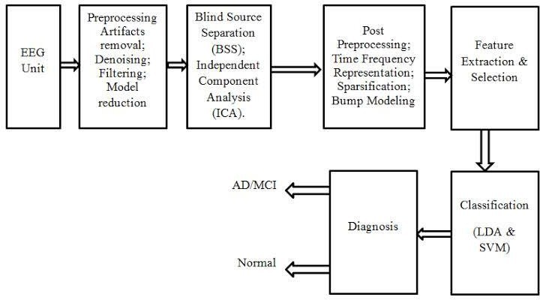

**SOFTWARE REQUIRMENTS**:

SCI-Lab Software

# METHODOLOGY:

## Generating EEG Signal with Noise:

In this code, we generate a basic alpha wave EEG signal and add random noise to simulate real-world EEG data. The resulting signal with noise is then plotted.

## Frequency Analysis of EEG Signal:

In this part, we perform a frequency analysis of the EEG signal with noise using the Fast Fourier Transform (FFT). The frequency components and their magnitudes are then plotted.

**WORKING CODE :**

// Define parameters

Fs = 1000; // Sampling frequency (1 kHz)

T = 1; // Duration of the signal (1 second) t = 0:1/Fs:T-1/Fs; // Time vector

// Generate a basic alpha wave EEG signal alpha_frequency = 10; // Alpha wave frequency (in Hz) alpha_amplitude = 50; // Alpha wave amplitude

eeg_signal = alpha_amplitude * sin(2 * %pi * alpha_frequency * t);

// Add random noise to the EEG signal noise_amplitude = 10; // Amplitude of noise

eeg_with_noise = eeg_signal + noise_amplitude * rand(1, length(t)) - noise_amplitude/2;

// Plot the EEG signal with noise subplot(2,1,1);

plot(t, eeg_with_noise, 'b'); title('EEG Signal with Noise'); xlabel('Time (s)'); ylabel('Amplitude');

// Frequency analysis

N = length(eeg_with_noise); frequencies = Fs * (0:N/2-1) / N; fft_result = fft(eeg_with_noise);

magnitude = 2 * abs(fft_result(1:N/2)) / N;

// Plot the frequency components subplot(2,1,2);

plot(frequencies, magnitude, 'r'); title('Frequency Components of EEG Signal'); xlabel('Frequency (Hz)');

ylabel('Magnitude');

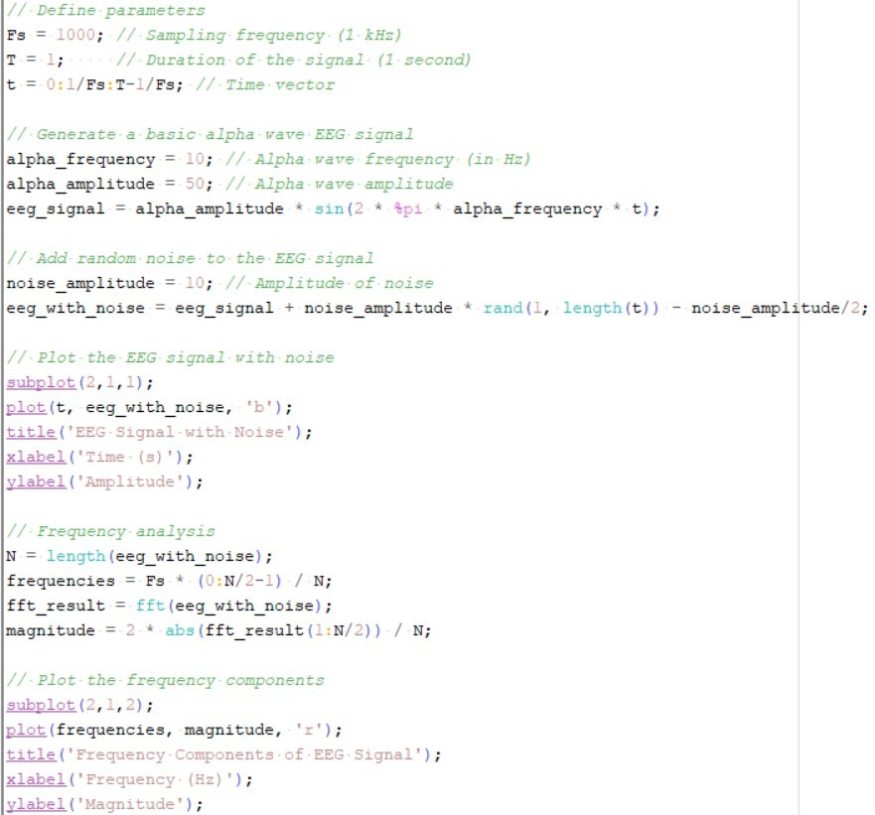

# OUTPUT:

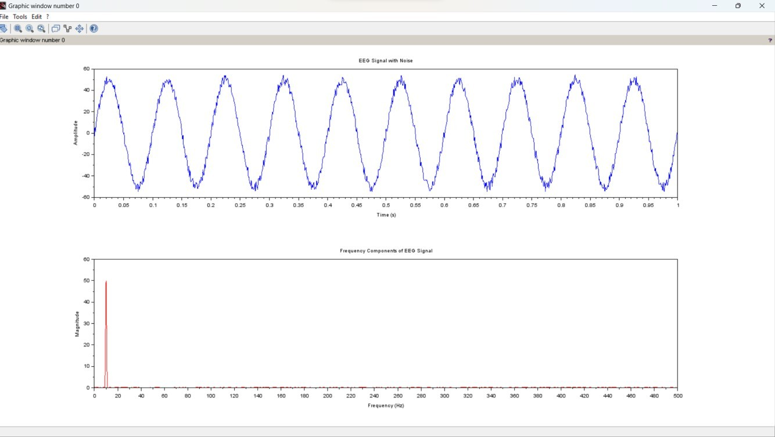

**CONCLUSION :**

In this mini project, we embarked on a journey to explore the world of EEG signal processing, from signal generation to the isolation of a specific brainwave component. The key findings and takeaways from this project are as follows:

Synthetic EEG Signal Generation:

We successfully generated a synthetic EEG signal resembling real brainwave activity, enabling us to create a controlled experimental environment.

**Noise Addition:**

By simulating noise and adding it to our synthetic EEG signal, we replicated the imperfections and disturbances that are commonly found in real-world EEG recordings.

**Frequency Analysis:**

The application of frequency analysis techniques, such as the Fast Fourier Transform (FFT), allowed us to transform the time-domain EEG signal into the frequency domain. We gained valuable insights into the spectral composition of our synthetic signal.

**Alpha Wave Isolation:**

Employing filtering techniques, we effectively isolated the alpha wave component (8-13 Hz) from the EEG signal. This step is crucial for various EEG-based studies and applications.

**Data Visualization and Interpretation:**

Through data visualization, we observed the changes in the EEG signal throughout the processing pipeline. This visual representation helped us understand the impact of noise, the distribution of frequencies, and the successful isolation of the alpha waves.

**Documentation and Reporting:**

Proper documentation is vital in research projects. We documented our methodology, parameters, and results, ensuring that the project can be replicated or extended for further exploration.

This mini project serves as a foundational exploration into EEG signal processing. It provides a hands-on experience in generating synthetic EEG data, simulating real-world conditions, conducting frequency analysis, and isolating specific brainwave components. The knowledge and skills gained from this project are valuable for those interested in neuroscience research, brainwave analysis, and bioinformatics. Moreover, this project can be extended and customized to address more complex EEG signal processing challenges and applications in the future.

# REFERENCES :

https://ieeexplore.ieee.org/Xplore/home.jsp